Author: Matthew Eaglman
Date Created: 1/19/2026
1/19/2026 Meeting Minutes
Find the meeting recording here: 2026-01-12 Meeting Recording.mp4
At the meeting we went over this artifacts document: 2026-1-12 Artifacts and assigned some tasks to people. Task assignments can be found on the artifacts document.
We went over the unity input system, and I actually said some incorrect information. In the meeting I said that for the movement I don’t want to be checking every single frame for input, but in this case it is actually ok. The events I was talking about will be useful later on when programming other inputs. Read more about unity’s input system here: https://docs.unity3d.com/Packages/com.unity.inputsystem@1.18/manual/index.html
We also went over the layout of the house: 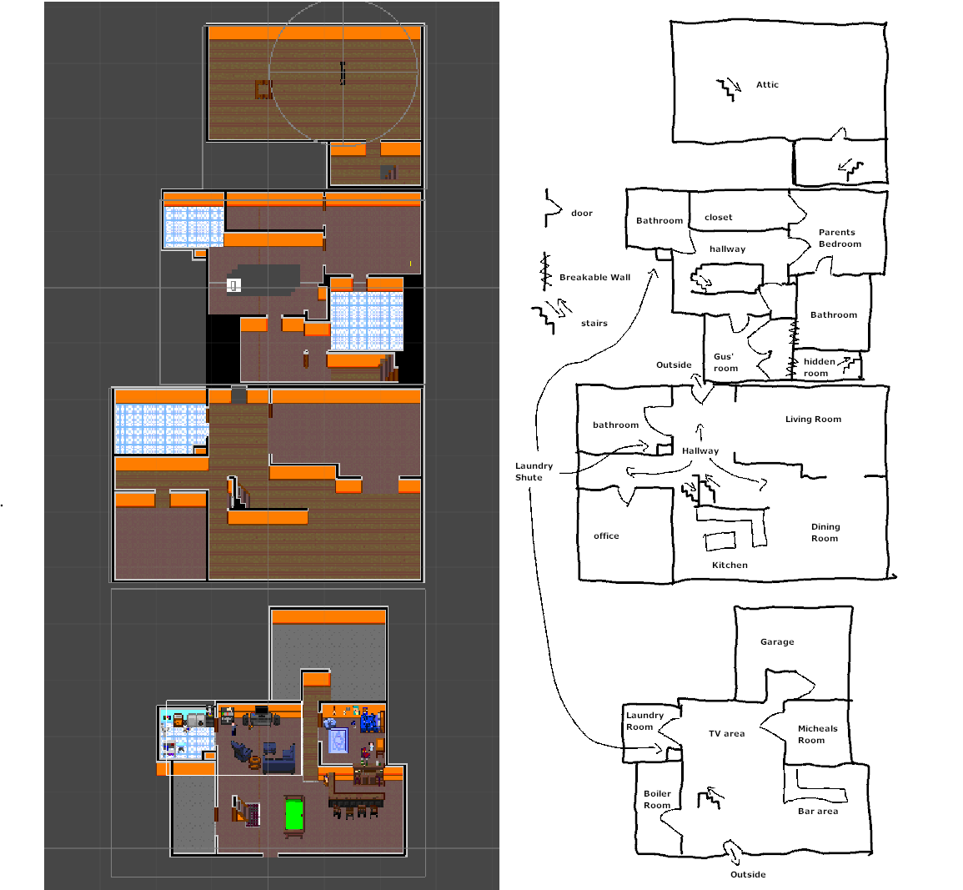
The rooms are roughly the right shape and size, if not a little too big. We will shrink them down to make sense with the furniture once we start getting furniture assets to place in the rooms.
The last thing we did was go over the unity layout, and a rough idea of how it works. This includes the programming and order of execution of different functions. Here is a unity page discussing order of execution: https://docs.unity3d.com/6000.3/Documentation/Manual/execution-order.html
If you want to watch the unity tutorialish type thing go to minute 26 of the meeting recording.

